

Reception Newsletter Spring 1

**We are so proud of all the children and their achievements so far.**

**Please make sure all items of uniform are clearly named, we have had multiple jumpers with no names and don’t know who it belongs to even after asking the children. These will be placed in lost property.**

**Talk for Writing**

.

**PE**

This half term we are very excited as we will be having a gymnastics coach.

RO PE is on Friday.

RR PE is on Friday.

**Website**

Check the class page on the school website [www.flixtonprimaryschool.org.uk](http://www.flixtonprimaryschool.org.uk) to see what has been happening in your child’s class. Check out the ‘gallery’ at the bottom of class pages for photos.

**Useful info**

Any queries please use the parent contact email

[parentcontact@flixtonprimaryschool.org.uk](mailto:parentcontact@flixtonprimaryschool.org.uk)

(please put your child’s class in the subject)

**Reception Vision Screening**

23rd January 2023

Conducted in school.

Our Talk for Writing text this half term will be ‘Lost and Found’. We will be learning about extreme environments like the arctic and what it is like to live there.

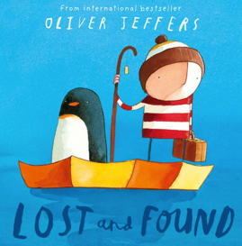

**Phonics**

We will be continuing our phonics learning following the ‘Phonics Shed’ scheme. We will be finishing off Chapter 2 and. Beginning Chapter 3. Keep an eye out for a Chapter 3 sound mats in book bags. You will continue to receive a letter each week informing you which sounds we are learning. Please practice these sounds along with formation at home. The letter will detail the rhymes we say to help children remember how to form the letters accurately. Key info:

Digraph = 2 letter making 1 sound

Trigraphs = 3 letters making 1 sound

We use zips (a line) underneath to highlight these in words.

**Maths**

In maths we will be learning how to make 5,6,7,8,9 and 10. Comparing numbers, combining amounts and building up to number bonds to 10.

We will also be exploring 3D shape which will include naming and describing properties.

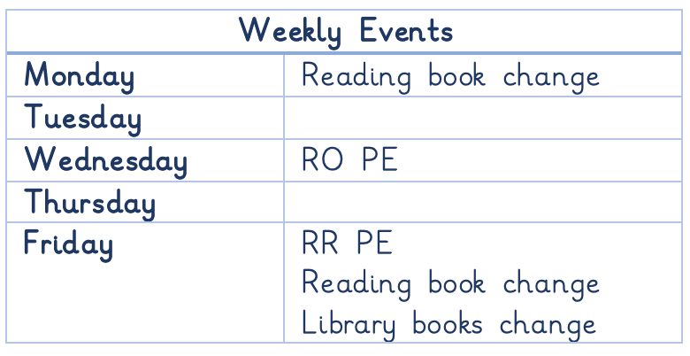

As we are in the cold weather season please ensure children come to school with a warm coat, hat, gloves and scarf when necessary. Please ensure every item of clothing is clearly labelled.

Puddle suits: Please ensure your child has a puddle suit so they can access the water and mud kitchen areas of the outdoor classroom. Again, please ensure it is clearly named.

Spare underwear: If anyone has any old underwear/underpants and would like to donate it to school it would be greatly appreciated as we are running low on spare underwear to change children.