

Reception Newsletter Spring 2

**We are so proud of all the children and their achievements, they are all individually making great steps of progress.**

**Please make sure all items of uniform are clearly named, including PE kits, wet suits and wellies.**

**Any unnamed items will be placed in lost property.**

**Talk for Writing**

.

**PE**

This half term we are very excited as we will be continuing our learning with our gymnastics coach.

RO PE is on Friday.

RR PE is on Friday.

**Website**

Check the class page on the school website [www.flixtonprimaryschool.org.uk](http://www.flixtonprimaryschool.org.uk) to see what has been happening in your child’s class. Check out the ‘gallery’ at the bottom of class pages for photos.

**Useful info**

Any queries please use the parent contact email

[parentcontact@flixtonprimaryschool.org.uk](mailto:parentcontact@flixtonprimaryschool.org.uk)

(please put your child’s class in the subject)

**Reception Vision Screening**

Conducted in school

Rescheduled from Spring 1, date TBC.

Our Talk for Writing text this half term will be ‘How to Catch a Star’.

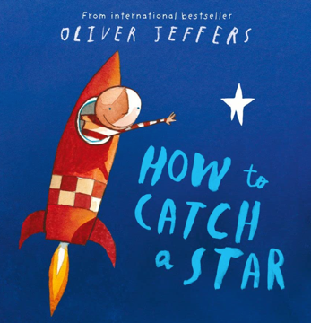

**Phonics**

We have been consolidating our knowledge on chapter 2 throughout spring 1 and will soon be ready to begin chapter 3. Keep an eye out for a Chapter 3 sound mats in book bags. You will continue to receive a letter each week informing you which sounds we are learning. Please practice these sounds along with formation at home. Please encourage children to write letters on the line in pencil.

Key information for chapter 3:

Digraph = 2 letters making 1 sound

Trigraphs = 3 letters making 1 sound

We use zips (a line) underneath digraphs and trigraphs to highlight these letters in words.

**Maths**

In maths we will be learning about:

* Length and height
* Time language to order and sequence events in a day and learn days of the week and use vocabulary ‘today, tomorrow, yesterday’.
* Counting to 9 and 10
* Comparing numbers to 10
* Number Bonds to 10.

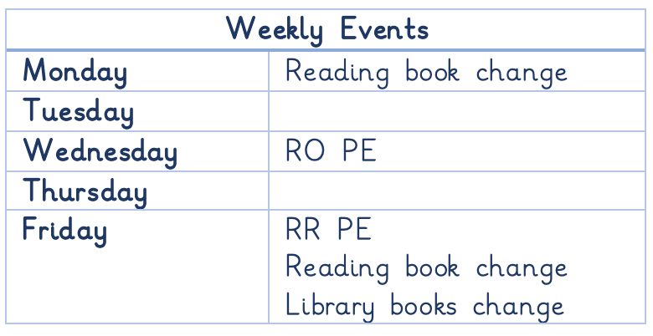

Spare clothes: If anyone has any old **underwear, underpants, tights,** and would like to donate it to school it would be greatly appreciated as we are running low on spare items to change children.

Donations for the mud kitchen: If you have any **old pans, baking trays, kitchen utensils** please send them into school so we can use them in our outdoor mud kitchen.