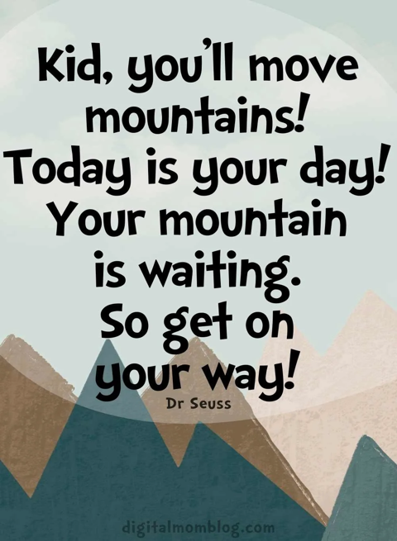

The coming term……

**These are the main aspects we will be covering**

English - using phonics to write words accurately, spelling tricky words accurately (Phase 4 and 5), applying the 4 basic sentence rules (capital letter, spaces, full stop, makes sense), begin to link sentences together to form a short narrative. We look at the story Stanley’s Stick and moving onto some non fiction writing and some poetry. We will also be focusing on our presentation and use of our cursive letters.

Phonics

We will be recapping phase 5 and then learning alternative spellings for sounds we know. We will be focusing on spelling all tricky words correctly as this is needed for children to reach the expected level by the end of Year 1.

*The Year 1 Phonics Screening check will be week commencing 12th June so please ensure your child is in school this week.*

Maths - count reliably with numbers to 100, order numbers within 100, add and subtract a 2 digit number to a 1 digit number, understand the value of numbers up to 100. We will also look money, measures and patterns.

Our other topics are…

Science – Plants and the Season Spring

History – Transport

Geography – An Island location

Art – Colour

Music – Round and Round

RE – What does it mean to be part of a community.

DT – Bread and Bug Hotels

Computing – My Online lIFE

PE - Gymnastics and running

PSHE – Being fake is a mistake

Year 1 Newsletter

Summer term

Image

A note on reading……

In order for your child to move around the reading racetrack you need to sign the book four times to say that they have read **4 times** in a week. As well as reading their school books please encourage a love of all things reading, library books, road signs, menus…. Always talk to your child about what they have read- comprehension is key.

Weekly reminders-

P.E.- 1H Tuesday and Thursday

1Y Tuesday and Thursday

Reading books in- Monday and Friday

Reading racetrack books in- Friday

Library books-1H Every other Tuesday

1Y Every other Wednesday

Image

Useful websites:

We have a number of websites/ apps that we use to support children’s learning, You are welcome to use them at home.

[www.oxfordreadingbuddy.com](http://www.oxfordreadingbuddy.com) online reading resource

[www.spellingshed.com](http://www.spellingshed.com) good practise for spelling year 1 words.

[www.phonicsplay.co.uk](http://www.phonicsplay.co.uk) lots of free games to help with phonics.

[www.topmarks.co.uk](http://www.topmarks.co.uk) maths games

[www.pobble.com](http://www.pobble.com) for stimulating and interesting pictures to promote discussion and writing