Phonics homework- Chapter 2 week 1

The sounds we have learnt this week are:

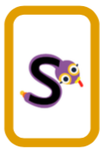 | Sam the Snake.  Makes the sound ‘s’. | The action is:  hands together and wriggle hands like a snake from chest up to face and over your head.
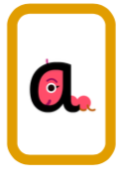 | Anna the Ant.  Makes the sound ‘a’. | The action is:  shake one finger and your head.
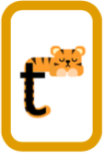 | Tom the Tiger.  Makes the sound ‘t’. | The action is:  tapping down the arm with one finger. (x5)
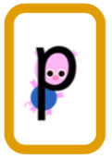 | Pat the Pig.  Makes the sound ‘p.’ | The action is:  pat head gently with one hand.

We have learnt to read the words a and at.
We have also learnt to read the tricky word ‘the.’

