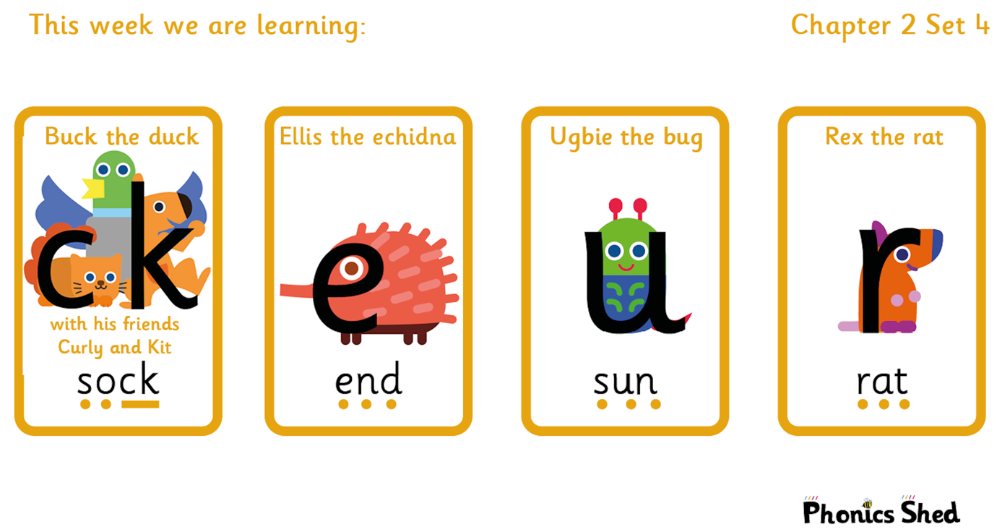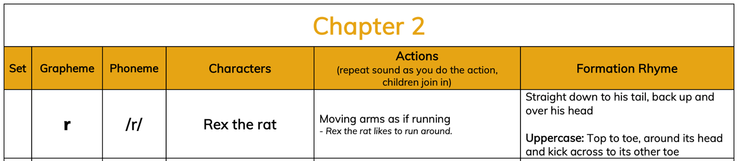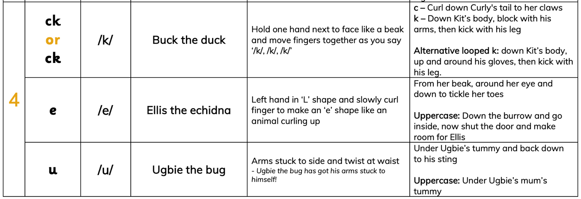

Tricky words to recognise by sight |  | Words to sound out and blend
I  to  do  go | the  into  no  so | cup  rat  net  sock  rock | tent  mend  peg  run  kick

