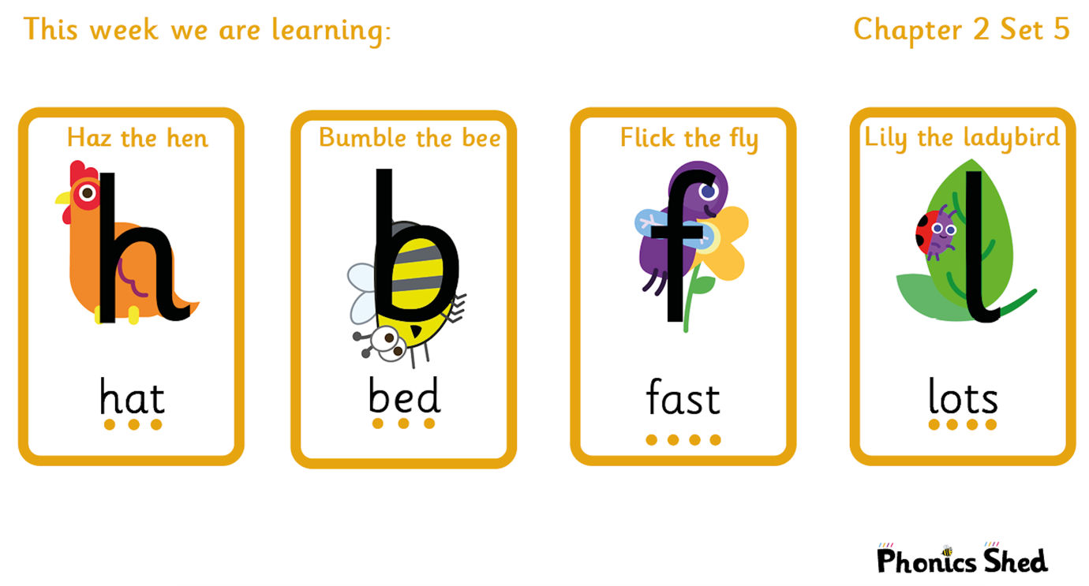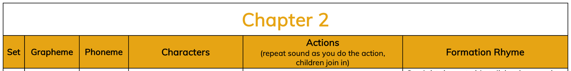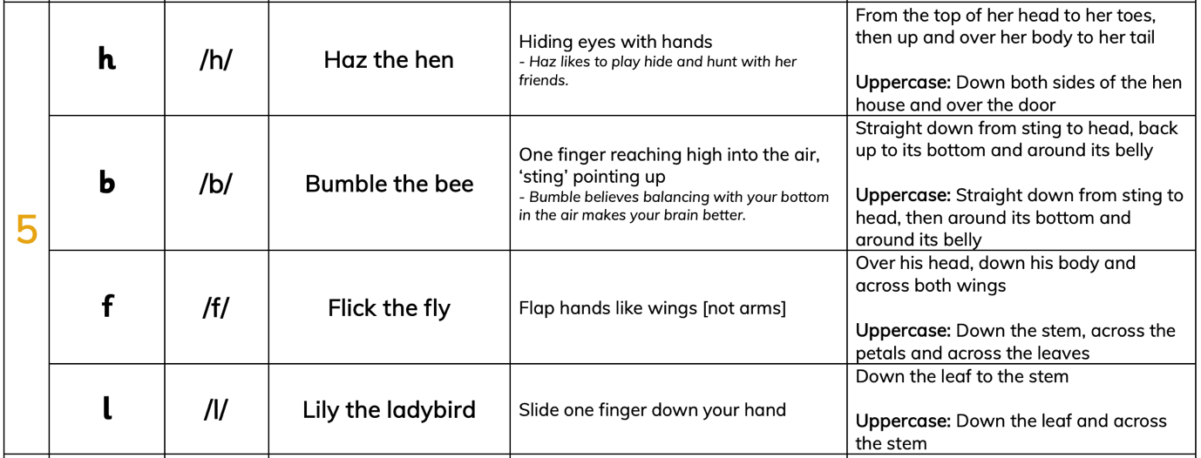

Tricky words to recognise by sight |  | Words to sound out and blend
I  to  do  no | the  into  of  go  so | him  had  fun  lamp  big  slip | hen  from  but  bat  lit  bin

