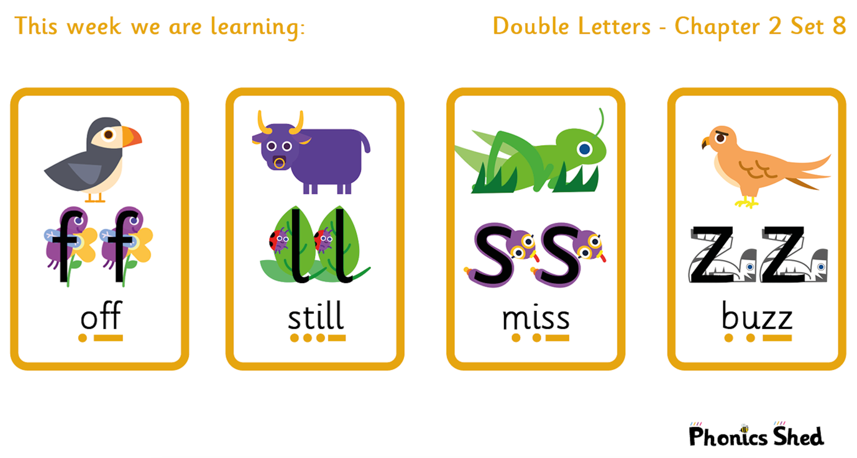
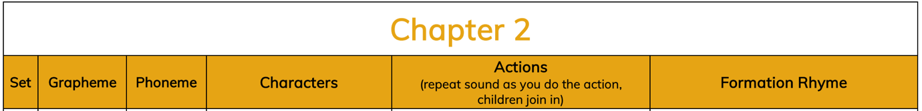
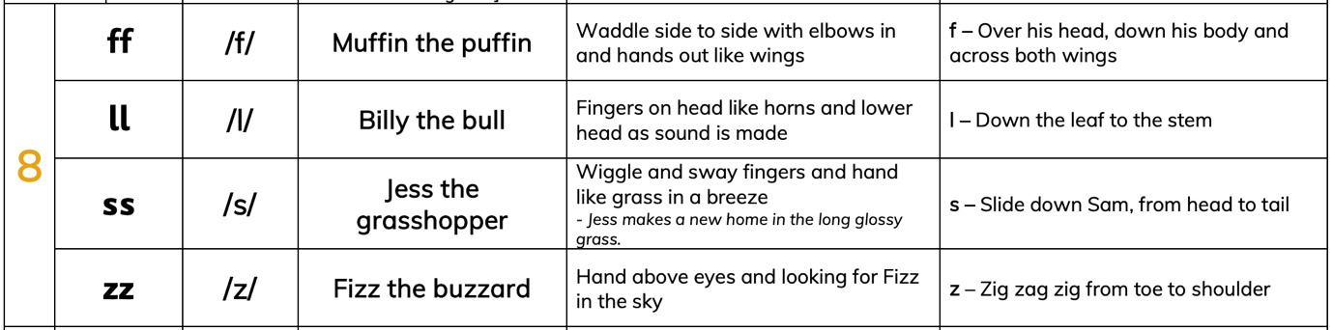

Tricky words to recognise by sight
I  to  do  no  want | the  into  of  go  so

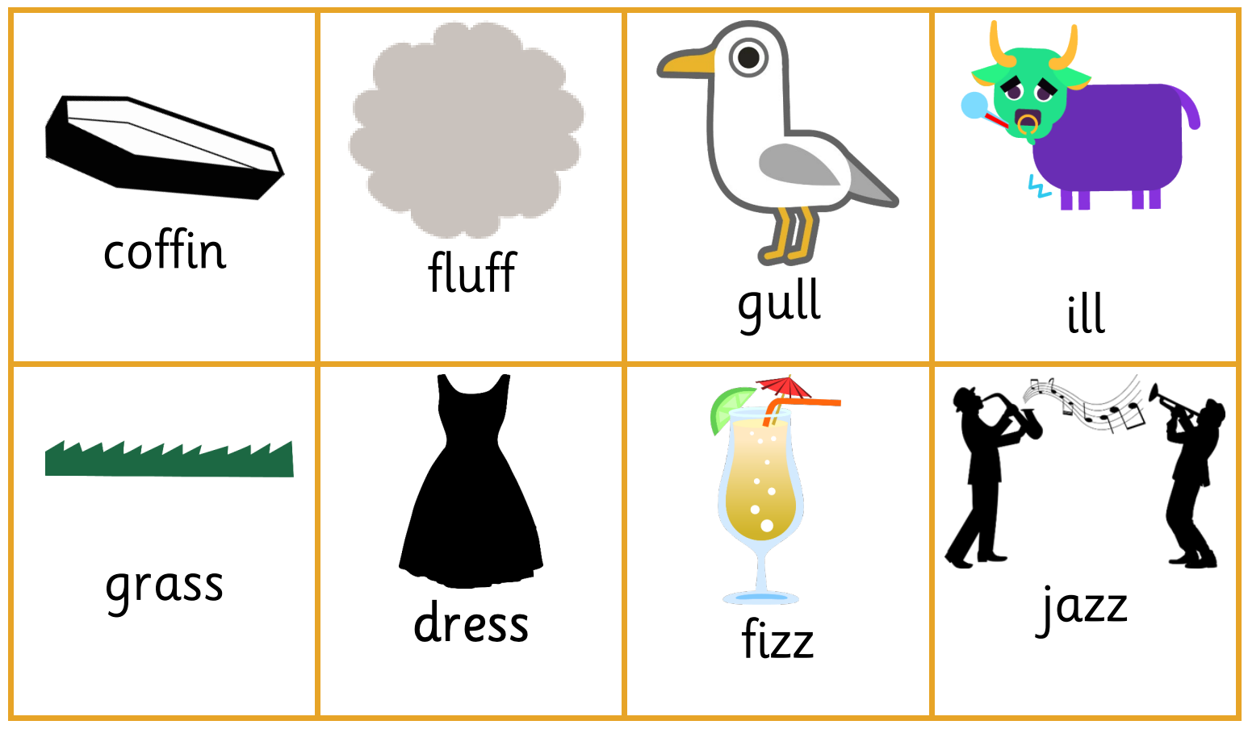
Add dots and zips under the words, sound each word out and blend to read:

