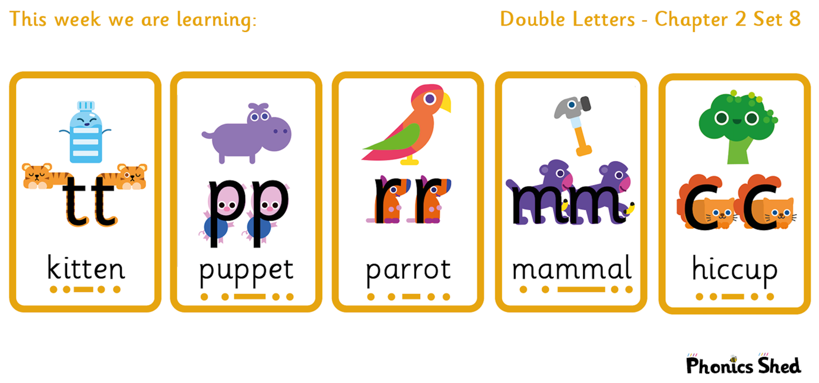
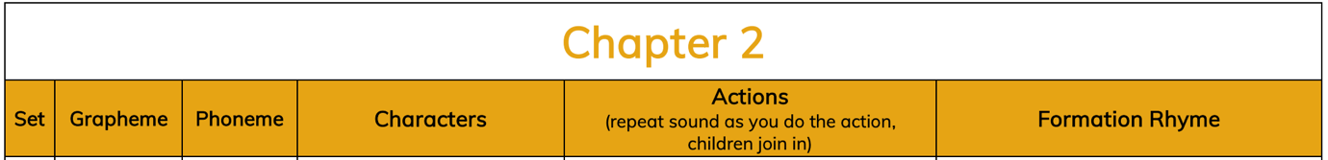
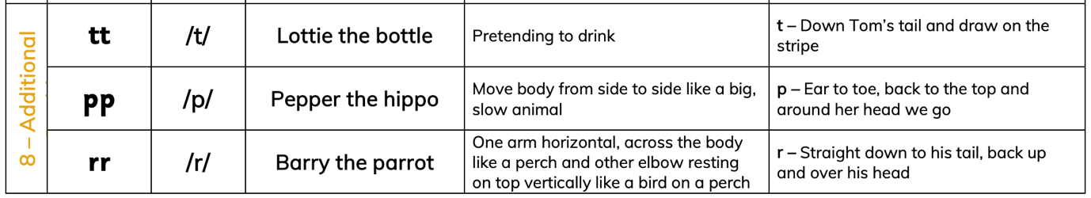
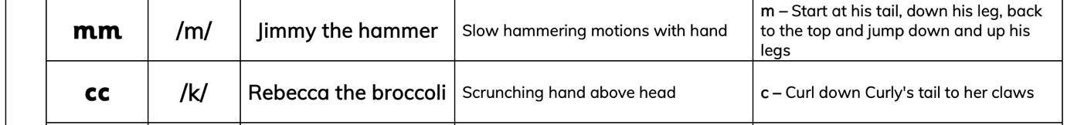

Tricky words to recognise by sight
I  to  do  no  want | the  into  of  go  so

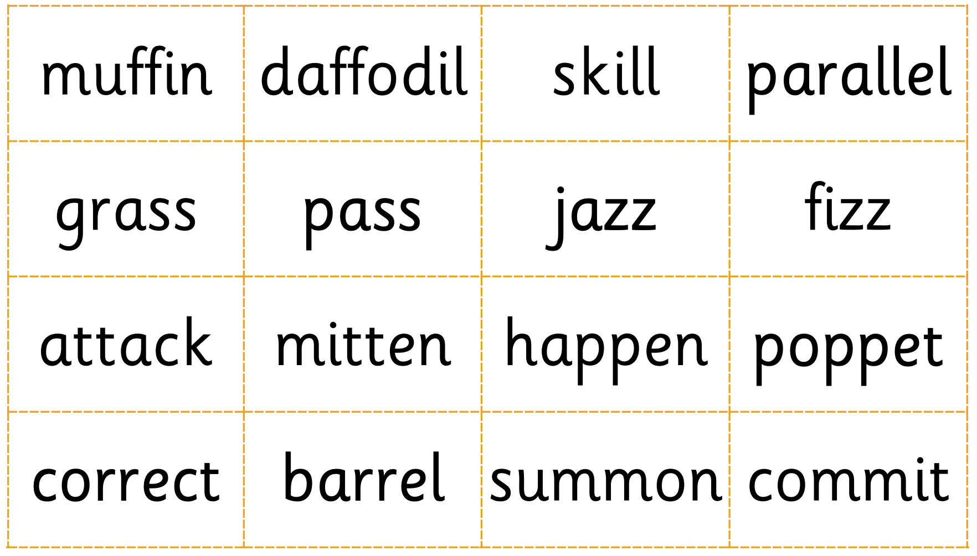
Draw zips ___ under the double letters:

