

Reception Newsletter Summer 1

**We are so proud of all the children and their achievements, they are all individually making great steps of progress.**

**Please make sure all items of uniform are clearly named, including PE kits, wet suits and wellies.**

**Any unnamed items will be placed in lost property.**

**Talk for Writing**

.

**Understanding the World**

We will be finding out about life cycles, growing and how we have changed since being a baby. Keep an eye out for some exciting events!

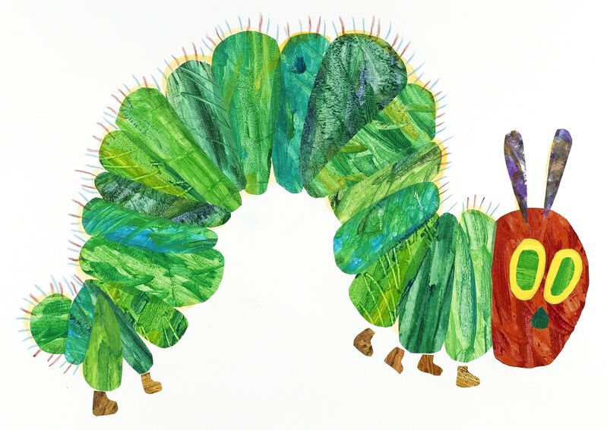

Our Talk for Writing text this half term will be ‘The Very Hungry Caterpillar’.

We will be learning all about change and growth linked to humans and other animals. We will also be comparing different environments.

**Phonics**

We have been enhancing our phonics knowledge learning many new sounds in Chapter 3.

Children will receive home learning on Friday linked to the phonics sounds we have been learning that week. Please encourage children to write letters on the line in pencil.

Key information for chapter 3:

Digraph = 2 letters making 1 sound

Trigraphs = 3 letters making 1 sound

We use zips (a line) underneath digraphs and trigraphs to highlight these letters in words.

**Maths**

In maths we will be learning about:

* Making 10 in different ways
* Odds and evens
* Sharing and grouping
* Number bonds to 10
* Using tens frames and part part whole models to support our learning.

Spare clothes: If anyone has any old **underwear, underpants, tights,** and would like to donate it to school it would be greatly appreciated as we are running low on spare items to change children.

Reminders:

Reading books -Monday and Friday

Library -Monday RO, Wednesday RJ

PE- Monday and Tuesday

**Website**

Check the class page on the school website [www.flixtonprimaryschool.org.uk](http://www.flixtonprimaryschool.org.uk) to see what has been happening in your child’s class.

**Useful info** Any queries please use the parent contact email

[parentcontact@flixtonprimaryschool.org.uk](mailto:parentcontact@flixtonprimaryschool.org.uk)

(please put your child’s class in the subject)