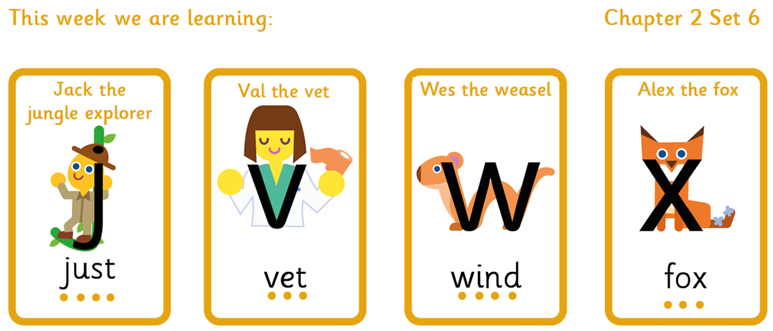
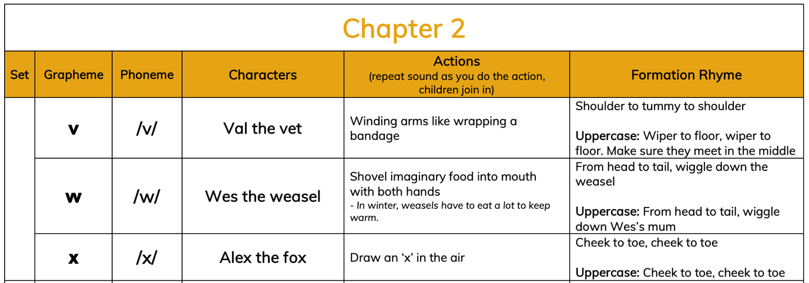

Tricky words to recognise by sight |  | Words to sound out and blend
I  to  do  no | the  into  of  go  so | fan  wet  jam  vest  van  win | fun  west  jump  jet  box  next

