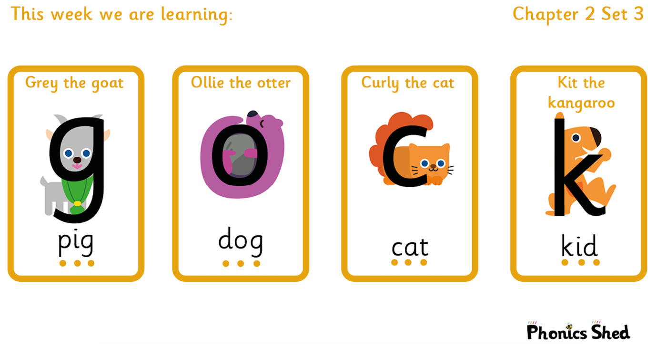
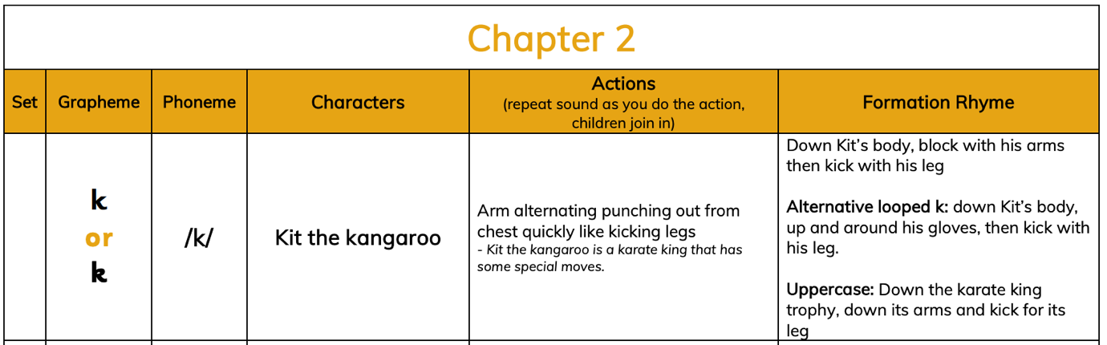
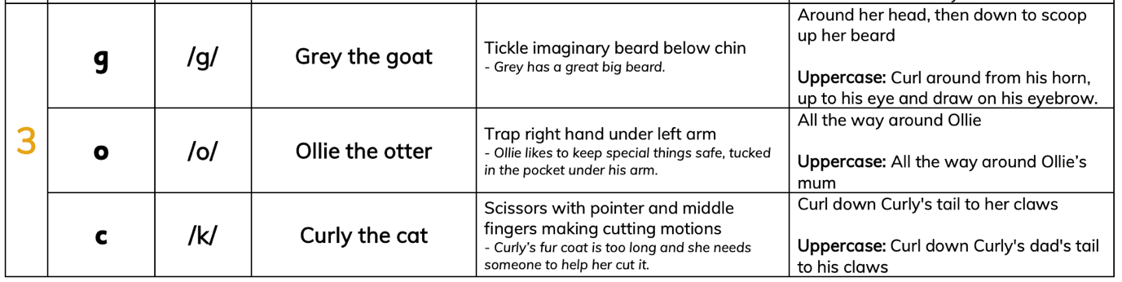

Tricky words to recognise by sight |  | Words to sound out and blend
I | the | dig  ink  mop  gig  kid | act  cog  gas  pond  skin

