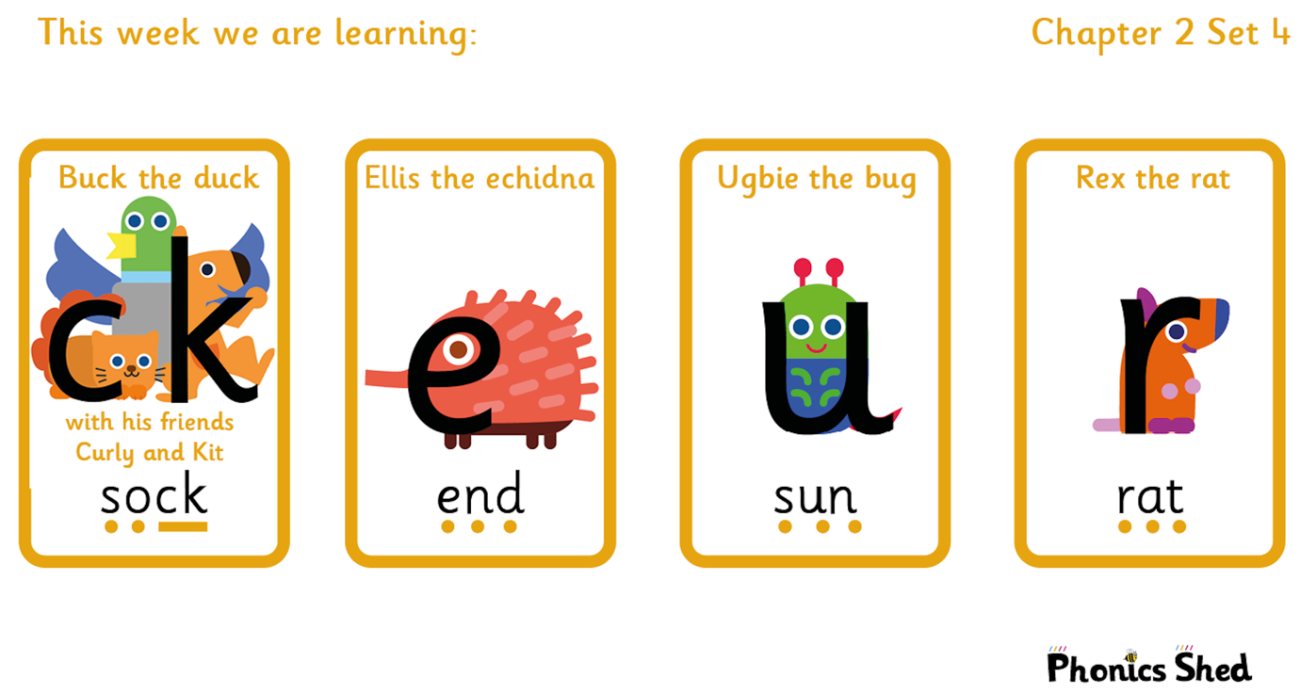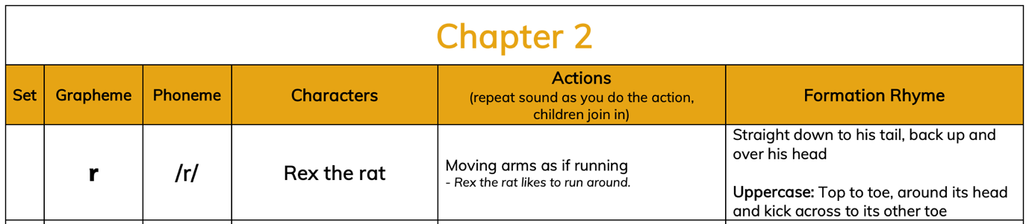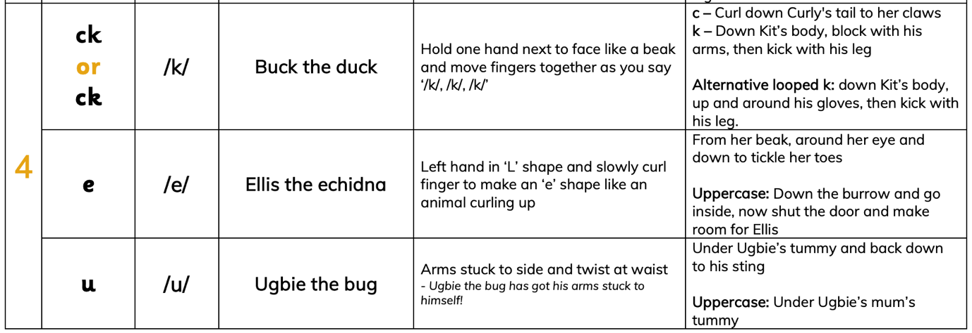

Tricky words to recognise by sight |  | Words to sound out and blend
I  to  do | the  into  no | cup  rat  net  sock  rock | tent  mend  peg  run  kick

