Read for fun this summer with Urmston Bookshop  If you would like to order any of the titles please complete this form and hand it in with the correct payment to the school office by Monday 17th July. |  | Nursery  Cost
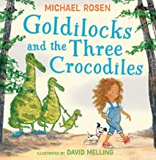 | Goldilocks and the Three Crocodiles by Michael Rosen  Goldilocks and her little dog are off on an adventure, looking for that house again – the one with the chairs, the porridge and beds and also some rather unexpected and hilarious inhabitants! | £7.99
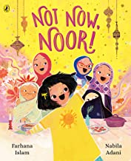 | Not Now, Noor by Farhana Islam  Noor loves her mum, and all the other hijabi women in her family, but wonders why do they wear headscarves? Is it so they can hide snacks for later? Or because they're a super spy and hiding their secret identity? Let’s find out! | £7.99
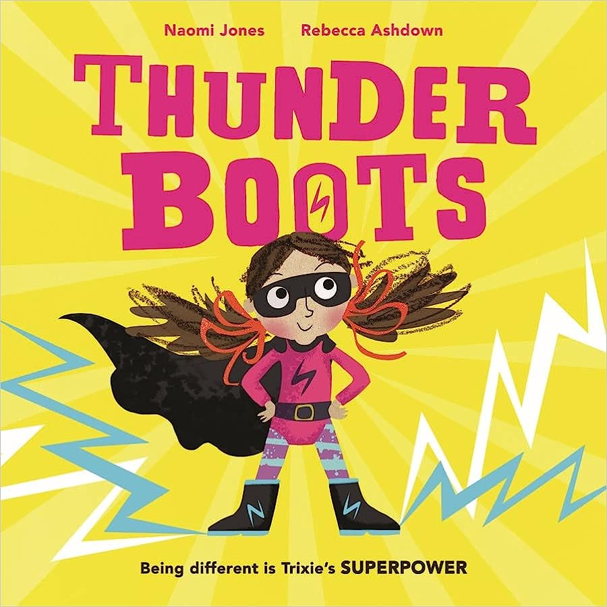 | Thunderboots by Naomi Jones  When it's time for Trixie to start school, she is very excited. Sometimes it's hard to concentrate in class, though. And it's really hard to read letters. Maybe what Trixie needs is a superpowered plan. | £7.99
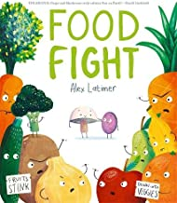 | Food Fight by Alex Latimer  The Fruits and the Vegetables have been fighting FOREVER! But best friends Grape and Mushroom decide it's time for things to change... | £7.99
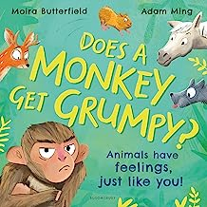 | Does a Monkey Get Grumpy by Moira Butterfield  Does a monkey get grumpy?  Do horses feel happy?  Can geese get glum?  What do you feel? | £7.99
Child’s Name _______________________________  Class ___________ |  | Total Paid:

Read for fun this summer with Urmston Bookshop  If you would like to order any of the titles please complete this form and hand it in with the correct payment to the school office by Monday 17th July. |  | Reception  Cost
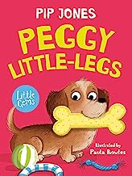 | Peggy Little Legs by Pip Jones  Peggy the sausage dog feels really sad when she finds she’s too small to really compete with the other dogs at puppy school.  But when one of her school friends has a dangerous fall, it’s Peggy who comes to the rescue, proving that heroes come in all different sizes! | £6.99
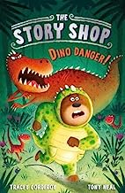 | Dino Danger! by Tracey Corderoy  Looking for adventure? Want to be a hero? Step inside the Story Shop!  The Story Shop is packed full of plots, costumes and characters galore. And shopkeepers Wilbur and Fred are ready and waiting to find every customer their perfect adventure! | £6.99
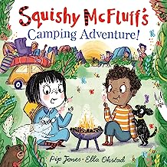 | Squishy McFluff’s Camping Adventure by Pip Jones  Ava is off on her first camping holiday! And of course Squishy will come too . . . But when Ava repacks Dad's bags with FUN camping accessories like her teddy, she forgets to include . . . the TENT! | £7.99
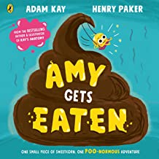 | Amy Gets Eaten by Adam Kay  This story follows Amy the sweetcorn on a funny, gooey and anatomically-accurate adventure through the human body as she discovers lots of facts about digestion. | £7.99
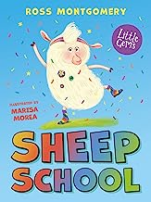 | Sheep School by Ross Montgomery  William the lamb’s feet are always tapping, ready to dance, and he loves nothing more than bursting into song. But his talents aren’t always appreciated at Sheep School. Cast out of the flock, he wanders miserably away only to witness the rest of the sheep being captured by the Big Bad Wolf... | £6.99
Child’s Name _______________________________  Class ___________ |  | Total Paid:
Read for fun this summer with Urmston Bookshop  If you would like to order any of the titles please complete this form and hand it in with the correct payment to the school office by Monday 17th July. |  | Year 1  Cost
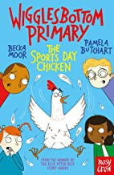 | The Sports Day Chicken by Pamela Butchart  Year 2 at Wigglesbottom Primary is never boring. They don't expect to run a race against a chicken at Sports Day, or eat green toxic slime at lunch (it's halloween custard!) or that Anne Marie Moor is an ant queen and one of her subjects is called Lady Gaga. BUT THEY LOVE EVERY MINUTE OF IT! | £6.99
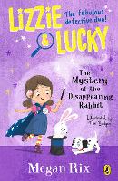 | Lizzie and Lucky – the Case of the Disappearing Rabbit by Megan Rix  Young detective Lizzie and her puppy, Lucky, are off to a magic show. But during the performance, a world-famous rabbit disappears - and not on purpose! Can Lizzie and Lucky find Rudy the rabbit, get to the bottom of who stole him, and why? | £7.99
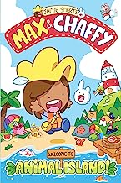 | Max and Chaffy – Welcome to Animal Island by Jamie Smart  Max has just moved to Animal Island and it's full of new friends: Orlando, Crumbs, Moose, Pedalo and a very special creature called a CHAFFY...  Now Chaffy is lost! So it's down to Max to find where Chaffy belongs . . . and YOU can help! | £6.99
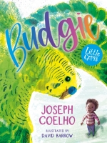 | Budgie by Joseph Coelho  Grumpy Mr Buxton seems to be keen to stop Miles and his friend enjoying the beautiful woods near where he lives. But, when Miles takes care of a lost little budgie, it leads him to finding a completely different side to Mr Buxton. | £6.99
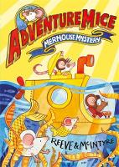 | Adventuremice – Mermous Mystery by Philip Reeve  Pedro is getting used to the thrilling life of the Adventuremice. But one stormy night, he finds something he's only ever dreamed of seeing: a real, live mermouse! This little mermouse is lost, and Pedro and the Adventuremice need to get him safely home. | £6.99
Child’s Name _______________________________  Class ___________ |  | Total Paid:

Read for fun this summer with Urmston Bookshop  If you would like to order any of the titles please complete this form and hand it in with the correct payment to the school office by Monday 17th July. |  | Year 2  Cost
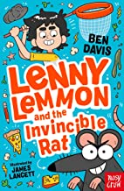 | Lenny Lemon and the Invincible Rat by Ben Davis  Lenny Lemmon is looking forward to Olden Days Day at school. It's a chance to break the routine and try school as it was years ago. But when the pet rat he sneaks in manages to escape, things start to go horribly wrong! | £6.99
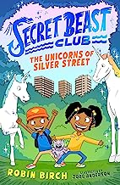 | Secret Beast Club – The Unicorns of Silver Street by Robin Birch  Aisha and Jayden are definitely not fans of Outside.  Aisha would rather be home playing on her tablet and Jayden thinks the worlds inside his books are much more exciting  But when they are asked to join the Secret Beast Club, Aisha and Jayden discover that real magic could be closer than they think. | £7.99
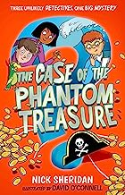 | The Case of the Phantom Treasure by Nick Sheridan  It's the school holidays in Snoops Bay, and Riz, Olly, Drew and Anton are looking for their next adventure. When they decide to visit the town's most unremarkable tourist spot, Bony Beach, they're shocked to discover a long-lost shipwreck that sunk to the bottom of the sea with treasure aboard. | £6.99
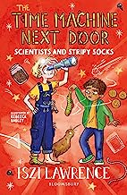 | The Time Machine Next Door – Scientists and Stripy Socks by Iszi Lawrence  Sunil and his extraordinary Auntie Alex are on a hilarious adventure whizzing through time. But Auntie Alex's time machine has started behaving strangely and using it has become even more unpredictable and dangerous than ever... | £6.99
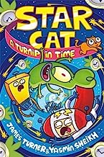 | Star Cat – A Turnip in Time by James Turner  Space has never EVER been so silly, so join Captain Spaceington and Co at the final frontier of laughter in this comic-strip comedy adventure! | £9.99
Child’s Name _______________________________  Class ___________ |  | Total Paid:

Read for fun this summer with Urmston Bookshop  If you would like to order any of the titles please complete this form and hand it in with the correct payment to the school office by Monday 17th July. |  | Year 3  Cost
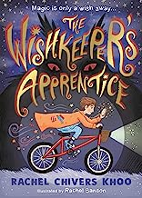 | The Wishkeeper’s Apprentice by Rachel Chivers Khoo  When Felix makes a very special wish, he doesn't expect to be offered a job as an apprentice to wishkeeper Rupus Beewinkle. Now Felix must save the town's wishes from the wishsnatcher, who wants to destroy hopes and dreams everywhere. | £7.99
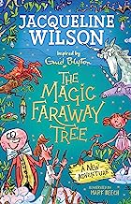 | The Magic Faraway Tree – a new adventure – Jacqueline Wilson  The Magic Faraway Tree is home to many remarkable creatures including a fairy called Silky, her best friend Moonface and more. It leads to many amazing Lands but not all of them are places you’d want to stay! | £7.99
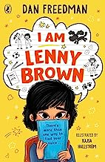 | I Am Lenny Brown by Dan Freedman  Lenny Brown is eight years old and can't talk. Except to his mum and his dog, Rocky.  When Lenny has to move house and start at a new school, it feels like his whole life is changing, and not for the better. Will he be able to make friends and find a way to fit in? | £7.99
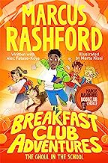 | The Breakfast Club Adventures – The Ghoul in the School by Marcus Rashford  The Breakfast Club Investigators haven't managed to solve a mystery in months and Marcus is worried that the group is going to break up! So when Gbenga, the captain of the school basketball team, comes to ask for their help Marcus knows this might just be the Investigator's last chance to prove themselves. | £6.99
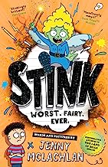 | Stink by Jenny McLachlan  We all know fairies. They’re sweet and sparkly and lovely. Right?  WRONG! Meet Stink. Stink is the rudest, naughtiest fairy there’s ever been. Instead of sparkles, Stink makes mess. Instead of being kind, Stink plays pranks. Oh, and she also eats woodlice and rides on rats! | £7.99
Child’s Name _______________________________  Class ___________ |  | Total Paid:

Read for fun this summer with Urmston Bookshop  If you would like to order any of the titles please complete this form and hand it in with the correct payment to the school office by Monday 17th July. |  | Year 4  Cost
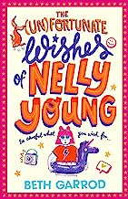 | The Unfortunate Wishes of Nelly Young by Beth Garrod  Secondary school is ninety-eight days away, which means I’m running out of time to break free from my totally embarrassing nickname Breaking News Nelly . . . Why did it have to be me who tripped playing netball and smashed a TV camera during the live report on our new sports hall opening?! I desperately need a relaunch, but it's hard when you have the worst luck in the world! | £7.99
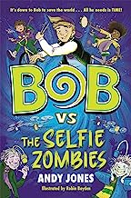 | Bob vs The Selfie Monsters by Andy Jones  When Bob accidentally time travels and comes face to face with his future self in the middle of a disastrous alternative reality, he knows has to do . . . something. An evil genius has created a smile-operated camera that turns people into zombies!  Now it's up to Bob to fix the present, to change the future, and save the whole world! If only he could figure out how. . . | £7.99
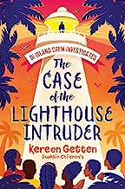 | The Case of the Lighthouse Intruder by Kereen Getten  Fayson's dream of becoming a detective finally comes true when her cousins recruit her to their top-secret gang. But when the gang fall out, Fayson takes charge and dives into the mystery surrounding a mysterious shadow haunting the island's lighthouse. | £7.99
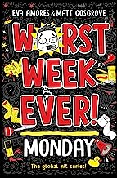 | Worst Week Ever – Monday by Eva Amores  His mum just married a vampire, his dad is driving a giant toilet on wheels, and his cat’s been abducted by aliens (probably). Justin Chase is having the WORST WEEK EVER! And that’s all before he’s even started his first day at a brand-new school. | £6.99
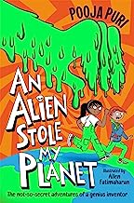 | An Alien Stole My Planet by Pooja Puri  Before you start reading, there are a few things you should know:  1. I, Esha Verma, am a genius inventor extraordinaire.  2. I like lists.  3. I did not mean to open up an inter-galactic portal. Some things just can't be helped. | £7.99
Child’s Name _______________________________  Class ___________ |  | Total Paid:

Read for fun this summer with Urmston Bookshop  If you would like to order any of the titles please complete this form and hand it in with the correct payment to the school office by Monday 17th July. |  | Year 5  Cost
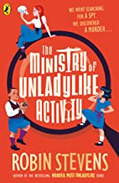 | The Ministry of Unladylike Activity by Robin Stevens  May knows that she would make the perfect spy. After all, grown-ups always underestimate children like her. And when they are turned down by the Ministry of Unladylike Activity, May and her friend Eric are forced to take matters into their own hands.  The first in a new series by the author of Murder Most Unladylike. | £7.99
 | Adam Wins the Internet by Adam B  There's nothing Adam wants more than to become a successful YouTuber, but it has always seemed impossible. Then one day a mysterious pop-up ad calling itself Popularis Incrementum promises to make ALL HIS DREAMS COME TRUE. Suddenly a world of FAME, FORTUNE and FANCY TVs awaits! Or does it?? | £7.99
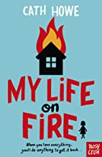 | My Life on Fire by Cath Howe  Ren's family lose their home in a fire. Ren lost her collection of things, her clothes - so Ren starts replacing things with other people's possessions. They've got loads of stuff, after all.  But she gets caught and has to strike a terrifying deal to avoid detection... | £7.99
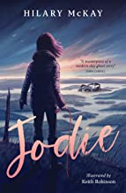 | Jodie by Hilary McKay  Jodie never wanted to come on the residential trip to the field centre. Jodie feels excluded and miserable, and eventually escapes out onto the salt marshes in search of a ghostly little dog she can hear barking in the distance. But the salt marshes are dangerous and Jodie gets trapped by the incoming tide. Stuck in the sucking mud, will anyone even notice that she’s gone? | £7.99
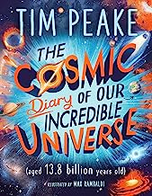 | The Cosmic Stars of Our Incredible Universe by Tim Peake  Told through the 'diary' of the Universe itself, along with astronaut Tim Peake and a host of space experts, this book takes you on a mind-blowing adventure to understand some of the REALLY BIG QUESTIONS about how our incredible universe came to be. | £7.99
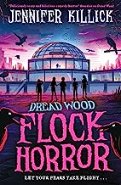 | Flock Horror by Jennifer Killick  Angelo and his friends know that together they can handle any pretty much anything – including giant mutant spiders or snake-like parasites that burrow into your brain. But when a terrifying new enemy attacks from above it seems they have met their ultimate match . . . how can they defeat giant vampire birds that are after BLOOD? | £7.99
Child’s Name ________________________Class__________________ |  | Total Paid:
Read for fun this summer with Urmston Bookshop  If you would like to order any of the titles please complete this form and hand it in with the correct payment to the school office by Monday 17th July. |  | Year 6  Cost
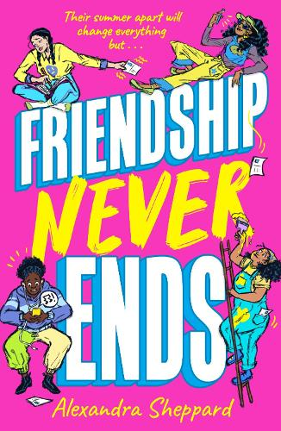 | Friendship Never Ends by Alexandra Sheppard  When you're figuring it all out, there are some friendships that mean the most. Meet Sunita, Gifty, Dawn and May. They're each about to have a summer they'll never forget, but does growing up have to mean growing apart? | £8.99
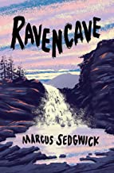 | Ravencave by Marcus Sedgewick  On holiday in Yorkshire, James is bored out of his mind being dragged around various old ruins as his dad tries to trace his family’s roots. Then one day James hears mischievous laughter and the ghost of a young girl appears to him at Crackpot Hall. When he goes after her, he makes a gruesome discovery that reveals a terrible truth about his family. | £7.99
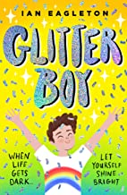 | Glitter Boy by Ian Eagleton  James’ teacher, Mr Hamilton, is getting married to his boyfriend and James will be part of a surprise choir performance at the wedding. But James's father seems uncomfortable about the plan, and about a lot of other things, too – will everybody’s secrets ever be revealed? Will James’? | £7.99
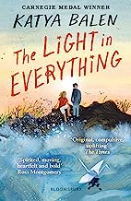 | The Light in Everything by Katya Balen  The story of Tom’s mum and Zofia’s dad – and the baby that neither Tom nor Zofia want. Until Tom’s mum gets ill and it might be too late to change their minds on that... | £7.99
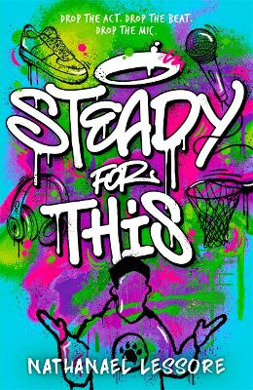 | Steady for This by Nathanael Lessore  Meet MC Growls, Wannabe Rapper and star of the show - but when a livestream practice goes epically wrong, Growls's dirty laundry is literally exposed. He's finally achieved his dreams of going viral – and it’s not in a good way. | £7.99
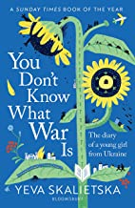 | You Don’t Know What War is by Yeva Skalietska  This is the gripping and moving diary of young Ukrainian refugee Yeva Skalietska. It follows twelve days in Ukraine that changed 12-year-old Yeva's life forever. She was woken in the early hours to the terrifying sounds of shelling. Russia had invaded Ukraine, and her beloved Kharkiv home was no longer the safe haven it should have been... | £9.99
Child’s Name _______________________________  Class ___________ |  | Total Paid:

