**Subject:** [2 of 2]: It's been an anxious year! Looking for ideas about how to support your child? BRAND NEW online course from the Solihull Approach (NHS)

Hello again,

It’s been an anxious year for many adults, children and young people alike. We know many of you are worried about the impact of the pandemic on your children.

**BRAND NEW!! Online course ‘Understanding your child’s mental health and wellbeing’ from the Solihull Approach (NHS).**

**Access for free:**

Did you know Trafford Council have PRE-PAID for every parent and carer in Trafford to access a course for parents/carers (access now for life-long access)? FREE (with access code: **WATERPARK** at:[www.inourplace.co.uk](http://www.inourplace.co.uk)) for residents in our area. There are courses for parents, carers and grandparents about children from bump to 19+ years.

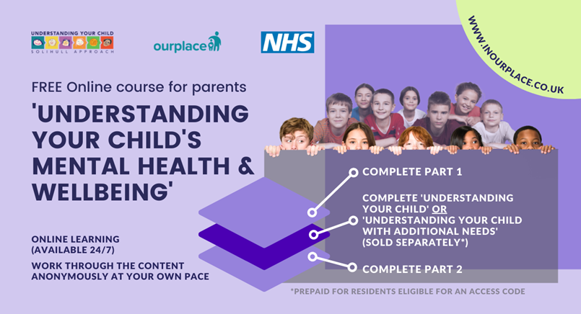

**How do I access?**

[www.inourplace.co.uk](http://www.inourplace.co.uk)

**What’s the code?**

* If you haven’t used it already here is the access code for all the online courses (funded for residents): **WATERPARK**
* If, like many parents, you have already used this code, log into your account [here](https://inourplace.heiapply.com/online-learning/login) and this course will be ready in your dashboard to start whenever you are ready.

**Can I tell my family and friends?**

Absolutely! Share the news with family members and other families in the area so that they too can take advantage of this fantastic opportunity.

**How long is it?**

‘Understanding your child’s mental health and wellbeing’ itself is in 2 parts (2 modules long in total):

1. Take **Part 1**….
2. …then take ‘**Understanding your child’** OR ‘**Understanding your child with additional needs’** (11 modules each taking 10-15 minutes to complete, benefitting from time to digest in between)….
3. …then take **Part 2**.

**If you like this…**

…you might like the other courses [**‘Understanding your teenager’s brain’ (short course)**](https://inourplace.heiapply.com/online-learning/course/35)or [**‘Understanding your child’s feelings’ (taster course)**](https://inourplace.heiapply.com/online-learning/course/40) , or other courses in the series.  [www.inourplace.co.uk](http://www.inourplace.co.uk)